|  |  |  |  |  |  |  |
| --- | --- | --- | --- | --- | --- | --- |
| Montag | **Dienstag** | Mittwoch | Donnerstag | Freitag | Samstag | Sonntag |
|  |  |  |  |  | 13:00-14:00  Pull&Press |  |
|  | 18:15-19:00  Bauch-Beine-Po | 18:45-19:45  Pull&Press | 18:30-19:30  Body Fit |  |  |  |
|  | 19:15-20:15  Zumba |  | 19:45-20:15  Fatburner / Bauchkiller | 19:00-20:00  Zumba |  |  |

Formel 1

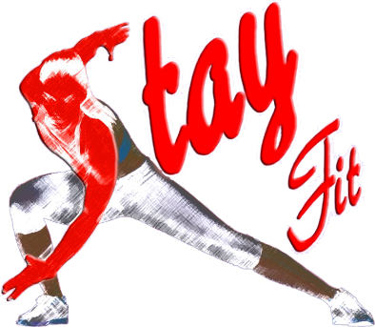

***Onlinekursplan***